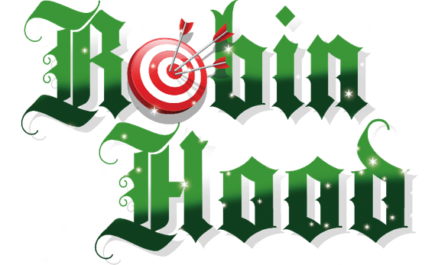
Oldham Coliseum Theatre is on the lookout for talented young actors aged between 9 and 12 to join the cast on stage for this year’s pantomime, Robin Hood. This year’s pantomime is Directed by Coliseum Artistic Director Chris Lawson and choreographed by Adele Taylor.

We are looking for three pairs of Babes, made up of both boys and girls, with great acting skills to play the roles.

Rehearsals will be up to three sessions a week from Monday 17 October until Saturday 5 November. For the final week before the first performances, (Monday 7 – Friday 11 November) the Babes will take part in technical rehearsals on the stage and will be required for longer sessions.

If chosen to play the part each young person will need to have approximately six full days and a half day off school for performances. The first performances are on Saturday 12 November 2022 and the last are on Saturday 7 January 2023. During this time, the three teams will perform in alternate performances, performing in approximately 30 performances each. You must have full availability over this period and be able to commit to your designated performance schedule.
Auditions will take place on the evening of Wednesday 21 September. There is no need to prepare anything in advance, but places should be booked. The session will include a drama workshop and some movement. Please attend in comfortable clothes and shoes you can move in and bring a drink. The first round auditions will be from 5pm, and recalls will take place later from 7pm.
To book a place, please email Rebecca Howarth, Administrator at rebeccahowarth@coliseum.org.uk. We will then send you an online registration form to complete by 10am on Friday 16 September.
Please note that places for the audition will be allocated on a first-come, first-served basis. If audition slots become full before the closing date we will not be able to accept further applications, so please apply early. If you have any questions, please get in touch with Rebecca via the email address above or by phone: 0161 629 1731.

