Create a Costume!
We recommend that this activity is suitable for young people aged 7+.
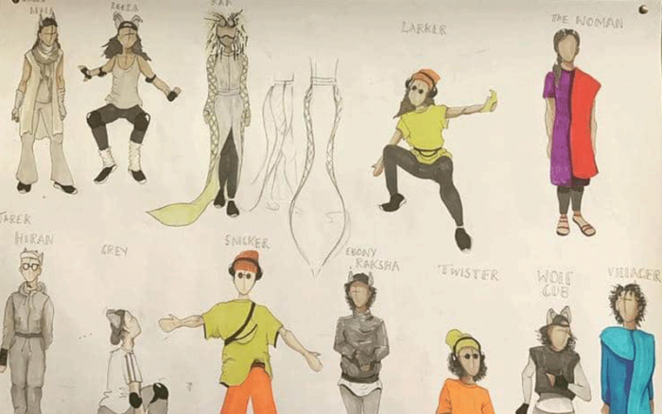
“Clothes make a statement, Costumes tell a story” – Mason Cooley
Have you ever watched a performance at the Coliseum and been amazed by the bright, extravagant costumes? Did you ever wish that you could wear a costume that transforms you into a completely different person? Had you ever hoped to design a theatrical costume yourself?
Well the Coliseum needs you to Create a Costume!

Take a look at our very own costume mannequins.
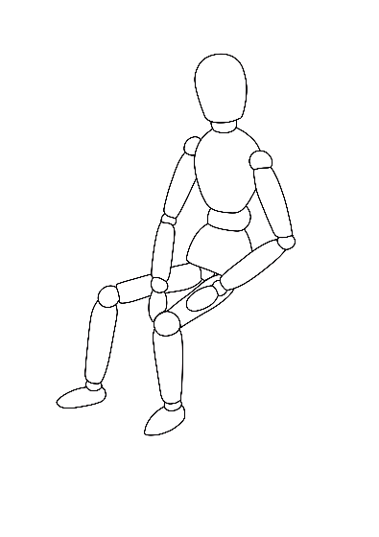
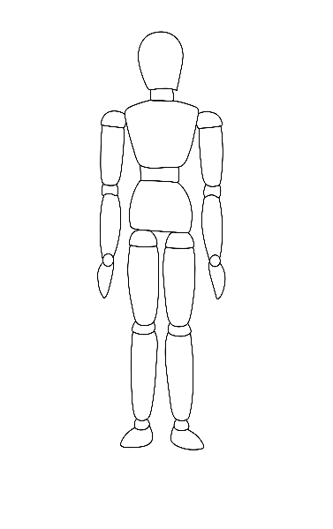
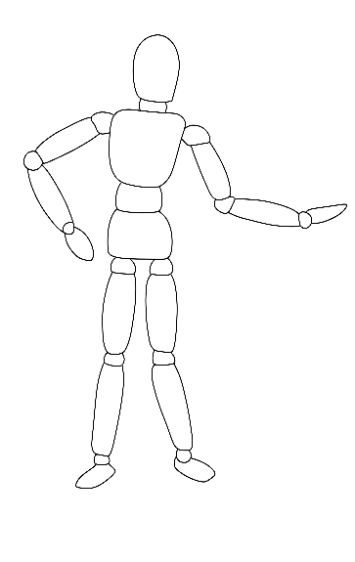

With your help, these mannequins will soon be different actors ready to take up the challenge of performing on a stage.
Here we have three descriptions of characters…
Anne Droid
Anne Droid is everyone’s favourite robot friend. They are made of every type of metal you can imagine, all of which are covered with hundreds of little buttons and dials. Anne Droid loves human clothes though, especially capes, as Anne Droid wishes to one day be the perfect hero…
Lady Wendy
Lady Wendy is an old-fashioned character. She loves wearing the perfect evening dress and wants everybody in the Kingdom to know that she is a lady of wealth. That’s right, Lady Wendy is rich! Bigger is better for Lady Wendy and she hopes her majestic dresses can impress all of the city-folk who may catch her whilst she’s on her way to the Opera or the Ballet….
The Rat King
The Rat King is a slippery little monster. Half-human and half-rat, he skulks his way through the sewers of Oldham, scheming to become the King of the entire planet. He might think he is powerful but when you look closely you can see that he silk waistcoat is now old and torn, turning into rags. Don’t forget to look out for his hideous ratty little tail…
We need you to draw over the attached mannequins the costumes you want these characters to wear onstage…
Be creative! How can you have fun with these costumes and create something that is breath-taking and memorable? Remember that a lot of theatres have hundreds of seats and you will need to be able to catch the eye from a far away distance.
Also have a go at writing your own character descriptions and designing their exciting costumes.
We would love to see your costume designs! Do remember you can use the hashtag #ColiseumCreates on all social media sites.
Do remember you must get your parent/guardian's written permission to send us your responses if you are under the age of 18.
