‘Off Out’ – Write a Monologue
We recommend this activity is suitable for young people over the age of 11.
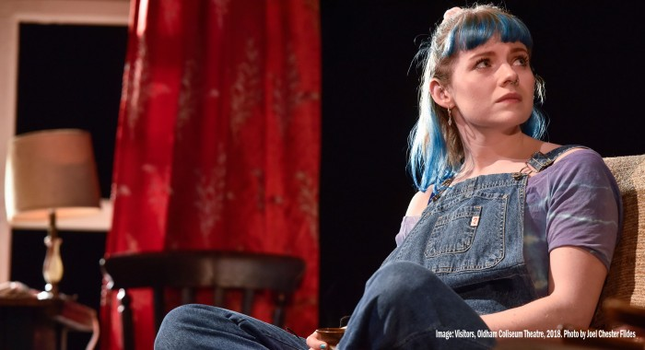
On Monday 23rd March it was announced by our government that everybody in the UK had to stay inside to help slow the spread of COVID-19. Each of us were permitted to go outside for food shopping, necessary work, and to exercise once a day.
We want you to cast your mind back to the beginning of the UK lockdown and to create a brand new monologue that focuses on a character’s daily trip out of the house during the beginning of these uncertain times.
What was their story? Were they about to leave the house to shop for an item they couldn’t live without? Had they just returned home from a peculiar encounter whilst out for a walk? Have a go at writing a speech that is super creative, teaches us something about an interesting individual and explores their relationship to the ‘outdoors’ at this time.
Have a look at our top tips below:

Top Tips:
- A monologue is a speech performed by one character. Usually in first person narrative, we learn all about a character’s inner thoughts and feelings. It’s best to tell the story from a character’s own perspective.
- Don’t worry too much about stage directions, think about making your character stand out as much as possible.
- Every single person has their own unique voice. How can you make your character’s voice sound different to everybody else’s?
- Make sure you give your monologue a captivating title.

We would love to read your monologues, or even see videos of you performing your creations! If you would like to share what you have created, remember you can use the hashtag #ColiseumCreates on all social media sites. Do remember you must get your parent/guardian's written permission if you are under the age of 18.

